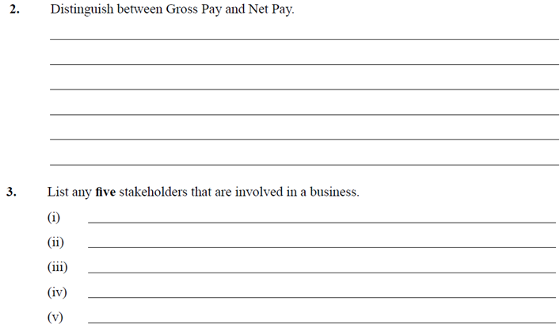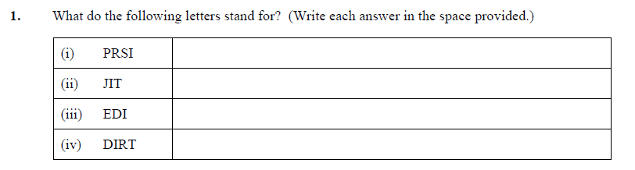

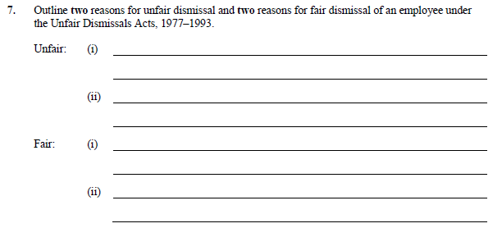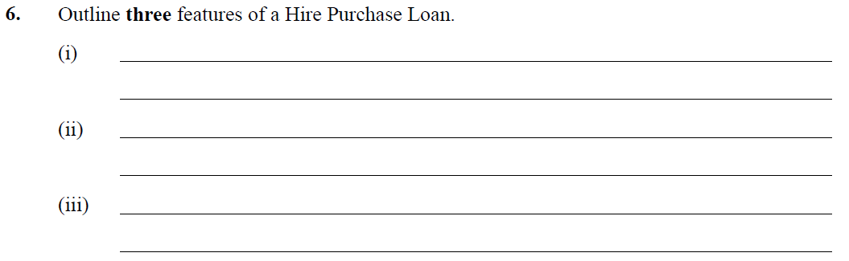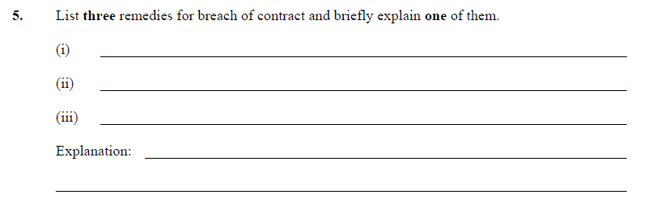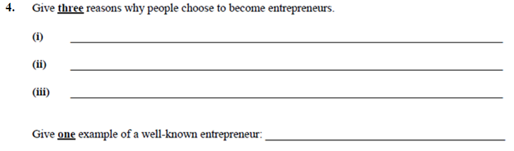

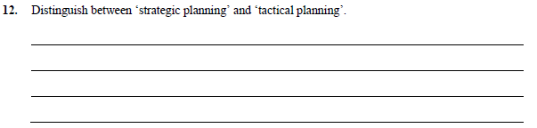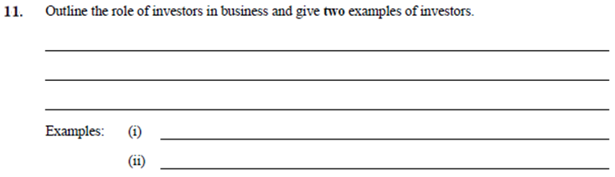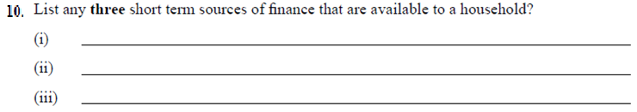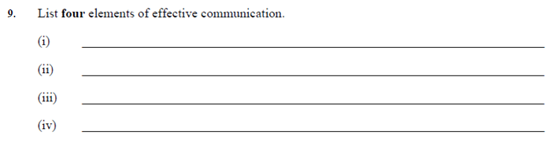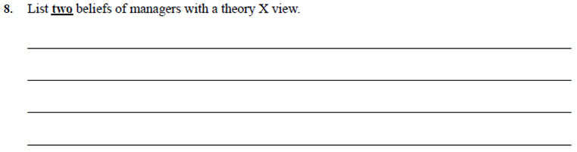

**QUESTION 1 – PEOPLE IN BUSINESS**

Read the information supplied and answer the questions which follow.

*A sales representative called to Alan McHugh’s home offering him a satellite television package. The sales representative told Alan their package was identical to his current cable television package but also included an internet service at a cost of €55 per month. This price was a much more competitive rate than his current provider and he signed up for the package. However, Alan, who is a keen sports fan, soon discovered that the sports channels that he used to receive were not part of this package and were only provided at an additional monthly charge.*

**(A)** Name the **law** that protects Alan McHugh in this case. (10 marks)

**(B)** Explain how **two** provisions (terms) of this law have been broken. (15 marks)

**(C) (i)** Identify the state agency that could advise Alan in this case.

**(ii)** Outline **three** functions of this agency. (25 marks)

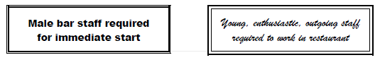

**(D)** Name the List **two** grounds on which discrimination presented in the above job

advertisements is outlawed. (10 marks)

**(E)** Trade Disputes, Shop Steward and Picketing are areas covered by the

Industrial Relations Act, 1990.

Explain **three** of the underlined terms. (15 marks)

**(75 marks)**

**QUESTION 2 – PEOPLE IN BUSINESS/ENTERPRISE**

### (A) Diana Prince earns €54,000 a year working for Wonder Ltd. Her Tax Credits are €1580 annually. The Standard cut-off point is €32,500

### She pays tax at 20% on cut-off point and 40% on the remainder.

### Her annual Union subscription is €16.50 per month and she pays

### PRSI at 4.75%. She pays USC as shown.

### 

### Calculate her total USC paid for the year.

**ii)** Calculate Diana’s net pay

**(B)**

Lensherr Metal Ltd. Is an Irish owned metal manufacturer based in a North Dublin suburb. It was founded 14 years ago by Erike Lensherr and Oscar Isaac, two friends who had their own metal fabricating business. From small beginnings the business has grown rapidly, and now employs 70 workers in a large factory in an industrial estate Lensherr sells mainly to DIY shops but also has a retail outlet that sells directly to blacksmiths and has its own website. The firm is known all along the east coast and has four vans on the road.

As a result of the construction recovery in Ireland, Lensheer has been doing very well. Erik and Oscar are good businessmen and also very ambitious. For some time now they have been considering expanding the business. Two years ago, in order to continue their expansion, they admitted two new shareholders as investors. They have looked at many options for expansion.

Lensherr employs a human resource manager and as a result a good industrial relations climate exists in the company. Most workers live within a two mile radius of the factory. The staff has a social committee that organises nights out. Regular customers have an account with the firm and get decent discounts on bulk purchases.

1. Outline the various types of taxes and types of insurance which you would

expect Lensherr to be familiar with.

Support your answer with reference to the text. (30 marks)

1. Explain **three** barriers to effective communication within the company. (15 marks) **(75 marks)**

**QUESTION 3 – ENTERPRISE/MANAGING**

Read the information supplied and answer the questions which follow.

**Esker Celtic Football Club**

Esker Celtic Football Club will hold its Annual General Meeting at the Esker Celtic clubhouse at 8.00 pm on Friday May 13th 2016.

The Chairperson Pat Cleary and Secretary Vanessa Mc Donnell are preparing for this meeting. A major concern for the club is improving its annual cash flow, and it is also considering upgrading the clubhouse facilities through a marathon fundraising day.



1. State **two** advantages of meetings as a method of communication. (10 marks)
2. Draft the Notice and Agenda of the Esker Celtic FC AGM, sent by

Vanessa Mc Donnell.

**(The Agenda must contain at least five items.)** (20 marks)

**(C)** Explain **two** reasons for a club to prepare a Cash Flow Forecast. (10 marks)

1. Outline **two** functions of the Chairperson at a meeting. (15 marks)

**(E)** Outline **two** ways in which the club could improve its annual cash flow. (10 marks)

**(F)** Explain, using an example what is meant by the term collateral. (10 marks)

**(75 marks)**

**QUESTION 4 – ENTERPRISE/MANAGING**



Aedín Brett, a qualified hairdresser and beautician has recently set up her own business in her home town after working five years in a large salon in Dundrum Shopping Centre. She noticed that people needed to take a step back from their daily busy lives and treat themselves now and again.

She has rented premises valued at €320,000 and has taken out a loan to equip it. She has employed two staff members full-time and two more part-time.

One night the girl on a Solas Apprenticeship Programme, Ms C Mc Sweeney, left a GHD plugged in overnight which caused fire damage to the value of €60,000 to the premises.

As Aedín was only starting out she only insured the premises for €280,000 with an excess policy of €750.

1. Describe **three** enterprising skills/characteristics that Aedín has an entrepreneur. (15 marks)
2. Describe **three** benefits to Aedín of setting up her own business. (15 marks)

**(C)** Describe **four** types of insurance that this business should have. (20 marks)

(You *cannot* use insurance on the premises as one of the types of insurance)

**(D)** Outline **two** details that the bank would have requested of Aedín before

granting her the loan. (10 marks)

**(E)** i) Using your knowledge of insurance calculate how much compensation

Aedín Brett is entitled to with regards to the fire. ii) Name the insurance rule that applied in this case. (15 marks)

**(75 marks)**

**QUESTION 5 – ENTERPRISE/MANAGING**

Kat Lynch owns and manages a medium-sized supermarket in a midland town. She joined a large, well-known franchise group in 2010 and modernised the supermarket by investing further capital in the business and obtaining a long-term loan from her bank.

In the last two years, sales in the business have fallen due to several economic and competitive factors. Kat has always adopted a democratic style of management and has a proactive approach to managing the business. She is currently looking at options to improve cash flow within the business and ways of cutting costs further by sourcing cheaper energy suppliers, carrying reduced stock levels, etc.

Kat spends long hours working in the supermarket and is determined to make the business a success. She recently introduced the idea of customers ordering online and offering a home delivery service.

**(A)** Outline **three** enterprising characteristics/skills displayed by Kat. (15 marks)

**(B)** Outline **two** methods by which Kat could successfully communicate her plans to improve cash flow to the stakeholders of the business. (10 marks)

**(C)** Other than Utmost Good Faith, state and explain **two** principles of insurance. (10 marks)

**(D)** Explain what a democratic style of leadership means and outline **two** benefits to the business of this style of leadership. (10 marks)

**(E)** Outline **two** responsibilities Kat has towards her employees. (10 marks)

**(F)** Illustrate how ‘stock control’ **and** ‘credit control’ can assist in the efficient

Management of the business. (20 marks)

1. **marks)**

